Name: Date: ue words

The long (u) sound is usually represented by the letters ue when it comes at the end of words, like in the words below.

Remember: Say the word aloud, then say each letter aloud as you write it e.g. 'due, d ... u ... e'
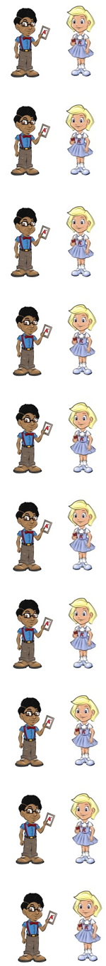
If a baby is due, that means it should be born soon.

A queue is a line that you wait in.

A cue is the stick that you use to play pool.

If you rescue (res/cue) someone, you save them.

The value (val/ue) of an item means how much it is worth.

If you issue (is/sue) something, you give it to someone.

If you continue (con/tin/ue) something, you keep doing it.

Nina and Gail always argue (ar/gue) with each other.

The words few and dew are naughty red words that belong to Nina and Neil because they use the letters ew to represent the long (u) sound at the end of words, not ue.
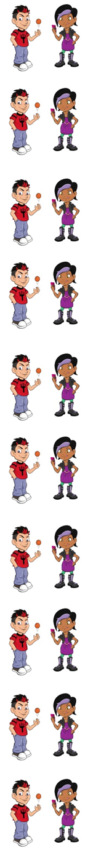
A few means not many.

Dew is water that you find on grass early in the morning.

Now test yourself without looking at the words and check for yourself if you got them all right. Practice writing any words that you made mistakes on again.

© www.SaveTeachersSundays.com 2013
Name: Date: ue words

The long (u) sound is usually represented by the letters ue when it comes at the end of words, like in the words below.

Remember: Say the word aloud, then say each letter aloud as you write it e.g. 'due, d ... u ... e'

Try to spell each word without looking at it.

If a baby is , that means it should be born soon.

A is a line that you wait in.

A is the stick that you use to play pool.

If you someone, you save them.

The of an item means how much it is worth.

If you something, you give it to someone.

If you something, you keep doing it.

Nina and Neil always with each other.

A means not many.

is water that you find on grass early in the morning..

Now check for yourself if you got them all right. Practice writing any words that you made mistakes on again.

© www.SaveTeachersSundays.com 2013

